# Generating a table

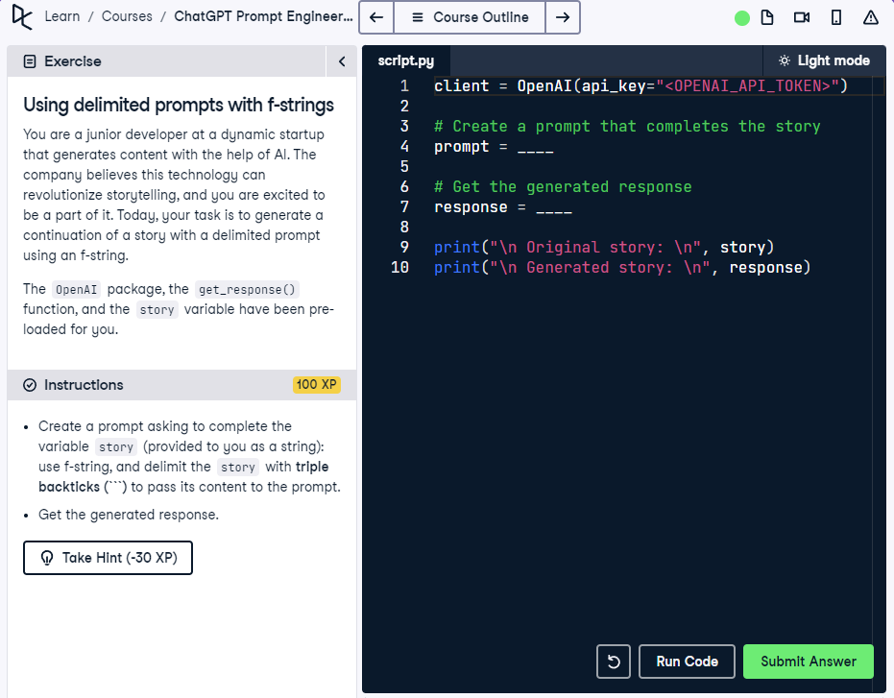

## Question

Generate a table containing 10 books for a science fiction lover, including Title, Author, and Year columns.

## Question Explanation

This task asks the model to generate a table with 10 recommended science fiction books. The output should include specific columns (Title, Author, Year) and be designed for someone who loves science fiction. The prompt is sent to the model using the get_response() function.

## Answer

client = OpenAI(api_key="<OPENAI_API_TOKEN>")  
  
# Create a prompt that generates the table  
prompt = "Generate a table containing 10 books I should read if I am a science fiction lover, with columns for Title, Author, and Year."  
  
# Get the response  
response = get_response(prompt)  
print(response)

## Answer Explanation

This version of the prompt clearly states the table should include 10 books suitable for a science fiction lover, and specifies the required columns: Title, Author, and Year. The prompt is direct and complete, enabling accurate and well-formatted results.